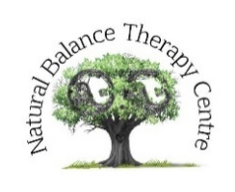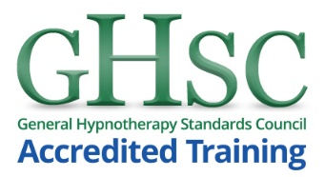
Hypnotherapy Scotland

DIPLOMA IN CLINICAL HYPNOTHERAPY (DHyp)
Professional Practitioner Training 2019

Name: Date of birth:

Address:

Email:

Contact Telephone No:

If you have had any mental or physical ill-health in the last few years please tell us about it here:

Please tell us of any professional experience you may already have as a therapist, if relevant:

Please tell us about any previous experience of hypnotherapy you may have:

Please tell us why you wish to train as a therapist and any other relevant info you think we should know about:

Payment details

Course Fee: £1950
Concession: £1450
Course fee is inclusive of all training and assessment costs.
Payment plan available: 10 monthly instalments.

BACS payment details:
Bank name: Nationwide Account Name: Dr J Wardrop
Account No: 79078437 Sort Code: 07-00-30

Contact:
Dr Julie Wardrop

juliewardrop@gmail.com
07427 607 380

